# PL/SQL Individual assignments 1

## Hirwa Roy 24174

**Step 1: Problem Definition**

**Business Context:** SIMBA Supermarket with online and on site stores wants to improve sales and customer targeting.  
**Data Challenge:** Sales are recorded per transaction across regions and channels; management needs to identify top products by region, monitor monthly charges and separate customers by spending so marketing can target high value groups.  
**Expected Outcome:** Provide top products per region/ period, monthly running totals and growth, customer spending in percentage, and 3 month moving averages to support inventory and marketing decisions.

**Step 2: Success Criteria**

1. **Top 5 products per region per quarter** — use RANK() or DENSE_RANK() to identify top 5 by revenue.
2. **Running monthly sales totals** — compute cumulative monthly revenue with SUM() OVER (ORDER BY month ROWS BETWEEN UNBOUNDED PRECEDING AND CURRENT ROW).
3. **Month-over-month growth (%)** — use LAG() to compute prior month revenue and % growth.
4. **Customer quartiles** — divide customers into quartiles by total spend using NTILE(4) (or CUME_DIST() for distribution insights).
5. **3-month moving averages** — compute 3-month moving average revenue with AVG() OVER (ORDER BY month ROWS BETWEEN 2 PRECEDING AND CURRENT ROW).

**Step 3: Database Schema**

Table customers {

  customer_id int [pk]

  customer_name varchar

  region varchar}

Table products {

  product_id int [pk]

  name varchar

  category varchar

  price decimal(12,2)}

Table transactions {

  transaction_id int [pk]

  customer_id int [ref: > customers.customer_id]

  product_id int [ref: > products.product_id]

  sale_date date

  quantity int

  amount decimal(12,2)}

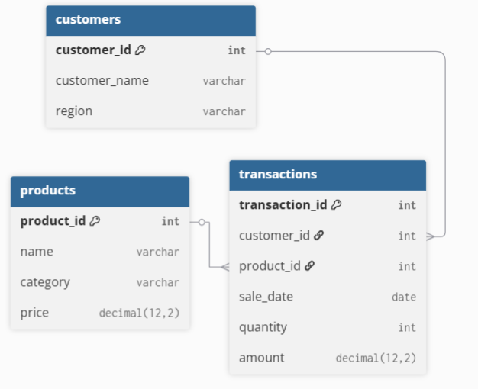

**Step 4: Window Functions Implementation**

Step 0: Sample Data Setup

--Drop tables if they exist

DROP TABLE IF EXISTS transactions;

DROP TABLE IF EXISTS products;

DROP TABLE IF EXISTS customers;

-- Create customers table

CREATE TABLE customers (

customer_id INT PRIMARY KEY,

customer_name VARCHAR(100),

region VARCHAR(50)

);

-- Create products table

CREATE TABLE products (

product_id INT PRIMARY KEY,

name VARCHAR(100),

category VARCHAR(50),

price DECIMAL(12,2)

);

-- Create transactions table

CREATE TABLE transactions (

transaction_id INT PRIMARY KEY,

customer_id INT,

product_id INT,

sale_date DATE,

quantity INT,

amount DECIMAL(12,2),

FOREIGN KEY (customer_id) REFERENCES customers(customer_id),

FOREIGN KEY (product_id) REFERENCES products(product_id)

);

-- Insert sample customers

INSERT INTO customers VALUES

(1001, 'John Doe', 'Kigali'),

(1002, 'Grace Uwimana', 'Butare'),

(1003, 'Eric Mukiza', 'Gisenyi'),

(1004, 'Alice Niyonsaba', 'Kigali'),

(1005, 'David Habimana', 'Butare');

-- Insert sample products

INSERT INTO products VALUES

(2001, 'Coffee Beans 1kg', 'Beverages', 25000),

(2002, 'Espresso Machine', 'Equipment', 250000),

(2003, 'Green Tea', 'Beverages', 15000);

-- Insert sample transactions

INSERT INTO transactions VALUES

(3001,1001,2001,'2024-01-15',1,25000),

(3002,1002,2001,'2024-02-05',2,50000),

(3003,1003,2002,'2024-01-20',1,250000),

(3004,1004,2003,'2024-03-10',3,45000),

(3005,1005,2001,'2024-03-15',1,25000),

(3006,1001,2002,'2024-02-18',1,250000),

(3007,1002,2003,'2024-03-20',2,30000);

**-- Step A: Ranking - Top 5 Customers by Revenue**

SELECT *

FROM (

SELECT customer_id,

customer_name,

total_revenue,

RANK() OVER (ORDER BY total_revenue DESC) AS revenue_rank

FROM (

SELECT c.customer_id,

c.customer_name,

SUM(t.amount) AS total_revenue

FROM customers c

JOIN transactions t ON c.customer_id = t.customer_id

GROUP BY c.customer_id, c.customer_name

) AS sub

) AS ranked_sub

WHERE revenue_rank <= 5;

**-- Step B: Aggregate - Running Monthly Sales Totals**

WITH monthly AS (

SELECT DATE_FORMAT(sale_date,'%Y-%m-01') AS month_start,

SUM(amount) AS month_total

FROM transactions

GROUP BY DATE_FORMAT(sale_date,'%Y-%m-01')

)

SELECT month_start,

month_total,

SUM(month_total) OVER (ORDER BY month_start ROWS BETWEEN UNBOUNDED PRECEDING AND CURRENT ROW) AS running_total

FROM monthly

ORDER BY month_start;

**-- Step C: Navigation - Month-over-Month Growth**

WITH monthly AS (

SELECT DATE_FORMAT(sale_date,'%Y-%m-01') AS month_start,

SUM(amount) AS month_total

FROM transactions

GROUP BY DATE_FORMAT(sale_date,'%Y-%m-01')

)

SELECT month_start,

month_total,

LAG(month_total) OVER (ORDER BY month_start) AS prev_month_total,

ROUND(

(month_total - LAG(month_total) OVER (ORDER BY month_start))

/ LAG(month_total) OVER (ORDER BY month_start) * 100,2) AS pct_growth

FROM monthly

ORDER BY month_start;

**-- Step D: Distribution - Customer Quartiles**

SELECT customer_id,

customer_name,

total_revenue,

NTILE(4) OVER (ORDER BY total_revenue DESC) AS quartile

FROM (

SELECT c.customer_id,

c.customer_name,

SUM(t.amount) AS total_revenue

FROM customers c

JOIN transactions t ON c.customer_id = t.customer_id

GROUP BY c.customer_id, c.customer_name

) AS sub

ORDER BY quartile, total_revenue DESC;

**-- Step E: Moving Average (3 Month)**

WITH monthly AS (

SELECT DATE_FORMAT(sale_date,'%Y-%m-01') AS month_start,

SUM(amount) AS month_total

FROM transactions

GROUP BY DATE_FORMAT(sale_date,'%Y-%m-01')

)

SELECT month_start,

month_total,

AVG(month_total) OVER (ORDER BY month_start ROWS BETWEEN 2 PRECEDING AND CURRENT ROW) AS moving_avg_3m

FROM monthly

ORDER BY month_start;

**-- Step F: Extra - PERCENT_RANK & CUME_DIST**

SELECT customer_id,

customer_name,

total_revenue,

PERCENT_RANK() OVER (ORDER BY total_revenue DESC) AS pct_rank,

CUME_DIST() OVER (ORDER BY total_revenue DESC) AS cume_dist

FROM (

SELECT c.customer_id,

c.customer_name,

SUM(t.amount) AS total_revenue

FROM customers c

JOIN transactions t ON c.customer_id = t.customer_id

GROUP BY c.customer_id, c.customer_name

) AS sub;